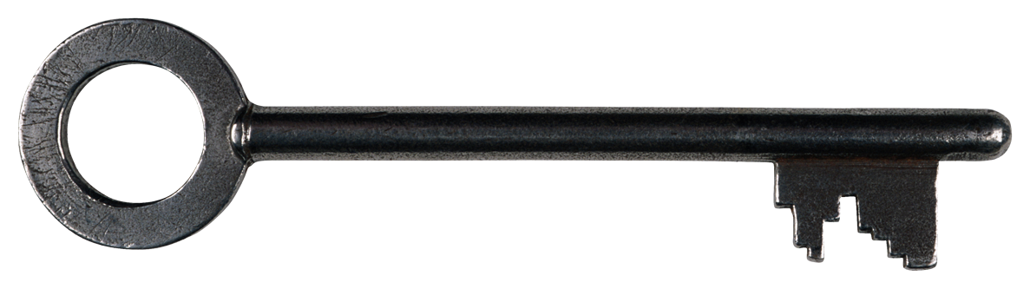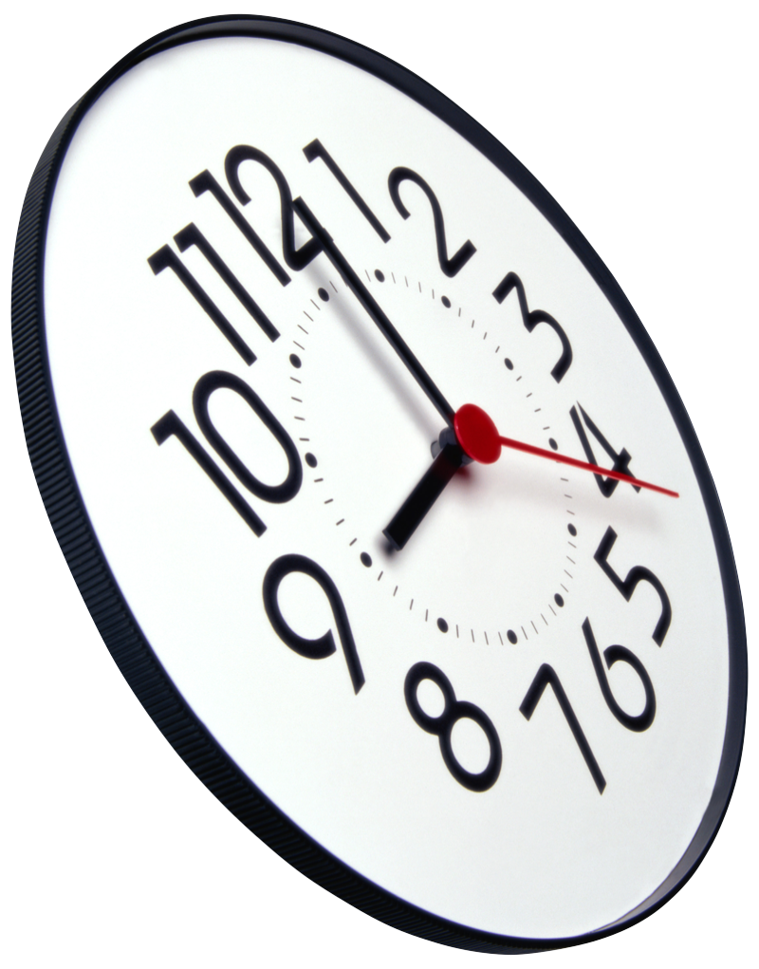 

Name

Date

# My Pledge to Take the Ride to Freedom

#### Carol L. Stokes, Esq. Presents:

Come Aboard and Take the Journey to Freedom!

Unlock the Journey to Freedom

# Commit To Your Supporters Today

So many times in life we wonder how to get the things we want in life. Often, we do not realize that being grateful for what we have is a huge key to what we desire showing up. How do we begin to create these desires? Start by giving thanks and making it a lifestyle and not an occasional task. Now is the time.

## Time to Stand Up for Good

THE NEW FREEDOM TRAIN

**The New Freedom Train**  
Post Office Box 5231  
Macon, Georgia 31208

www.CarolLStokes.com

Make a Pledge to ride The New Freedom Train to a new way of life – a life filled with choices that honor you and your loved ones. Symbolize and memorialize your commitment below by signing and dating where indicated. No one will watch you. This, you do for yourself and your loved ones.

The more you modify a few habits, make a few sacrifices and say no to spending your money with those who do not value you, you will be heard and yours and your children’s lives can and will change for the better. This is the greatest honor you can give yourself and your children. It’s called self-respect!

Look at it this way: When you receive your paycheck, do you put money in someone else’s bank account or in your own? You can only enrich yourself and your future generations by giving back to yourself. This pays it forward. You must also give back by giving to others - those who support and build you and give back to you too.

# Paying it Forward and Backward

Consciousness is simply awareness. There is a true sense and understanding of matters. Having a good grasp of what occurs in our lives and what happens around us, and who is involved in the things that matter and affect our lives and our children’s lives, actually makes a difference. We, too, can affect outcomes.

# Honor Thy Self

### Consider These …

# Where you buy clothing

# Whose label is on your clothing

# Where you buy groceries

# Where you buy your car

# Where your child attends school

# Which restaurants at which you dine

# Where you bank

# Where you socialize

# The list goes on and on but you can take it from here.

# Your Money Counts and So Do You …

Once we become aware of how institutions and businesses are operated and the people who support and operate them, we have an obligation to make certain choices and decisions accordingly. Whether the business is local, a national chain or otherwise, the question should be whether to conduct business with it at all. The money we spend in our daily lives serves someone. Naturally, it serves the provider of goods and services but it should also serve the customer who made it all possible.

Spend money with people who respect you, see you as their equal and honor you enough to support and invest in your community.

### Be Heard

# Consciousness. What is it?

Support Your Supporters

*You might have heard that a smile is contagious. If one smile can travel to persons unknown, imagine how far gracious acts of pure goodness and kindness can spread across the planet.*

Gratitude Moves the World Forward

When your sheer existence or voice is considered non-existent or invalid, consider being heard through something that is never disregarded – your money.

Empowerment